High-yielding cultivar “Takanari” shown over competition to “Koshihikari” on nitrogen absorption and biomass production under natural rice farming

Jean Yves Dukuzumuremyi¹, Christian Nkurunziza², Margi Asih Maimunah², Yuka Sasaki¹, Murayama Hedeki¹, Weiguo Cheng^{1,2}

¹Graduate School of Agricultural Sciences, Yamagata University, Tsuruoka, Japan
²The United Graduate School of Agricultural Sciences, Iwate University, Morioka, Japan

Rice yield and whole biomass production are strongly related to the rice cultivar's nitrogen (N) uptake ability and various meteorological conditions and managemental practices. Previous studies showed that Takanari as a high-yielding Indica rice cultivar has higher N uptake ability compared to regular japonica cultivar, such as Koshihikari under low nitrogen supply even if the atmospheric CO₂ concentration was increased. However, it is still unclear that the N uptake competition between Takanari and Koshihikari under natural rice farming without any manure and fertilizer application. For this reason, we conducted a pot experiment at Tsuruoka, Yamagata, Japan in the 2022 rice growing season.
Both Takanari (Tak) and Koshihikari (Kos) were transplanted into individual pots and interplanting pots (Tak+Kos) with main treatments of weeding and unweeding. The main treatment was weeding and unweeding. The sub-treatments were individual cultivation (Tak, Kos) and interplanting cultivation (Tak+Kos). The pots were filled with 8.0 kg air-drying alluvial soil which was taken from an organic rice farming field in Yamagata University Farming. Rice seedlings of both varieties were transplanted on 28th May and Harvested on 19th September 2022; then rice plants were divided into the ear, leaf+ stem, and root to be assessed for biomass and N content.
As a result, plant biomass and nitrogen content were significantly different among all treatments. Comparing Takanari to Koshihikari, Takanari accumulated a higher amount of biomass and nitrogen content for ear, root, and whole rice plants in both treatments (weeding and unweeding); whereas, Koshihikari accumulated a higher amount of biomass and nitrogen content for Leaf+stem in both treatments (weeding and unweeding). The Takanari-Koshihikari ratios of total dry weight biomass were 1.20 and 1.34, when each cultivar is grown individually in the pot for weeding and unweeding treatments, respectively. Whereas they were 1.36 and 1.56 when two rice cultivars were grown in the same pot as interplanting cultivation (P<0.001). Then, the Takanari-Koshihikari ratio of the total N uptakes was 1.33 and 1.32, when each cultivar was grown individually in the pot for weeding and unweeding treatments, respectively; Whereas they were 1.62 and 1.48 when two rice cultivars grown in the same pot for weeding and unweeding treatments, respectively (P<0.001). The results indicated that Takanari expanded competition on N absorption and biomass production to Koshihikari when two rice cultivars were grown in the same pot as interplanting cultivation.

Keywords: Planting System, Organic farming; Rice variety; Weeding

Corresponding author: Jean Yves DUKUZUMUREMYI
Position: Master student
Affiliations: Graduate School of Agricultural Sciences, Yamagata University, Tsuruoka, Japan
Country: Japan
E-mail: dukuzyves@yahoo.fr
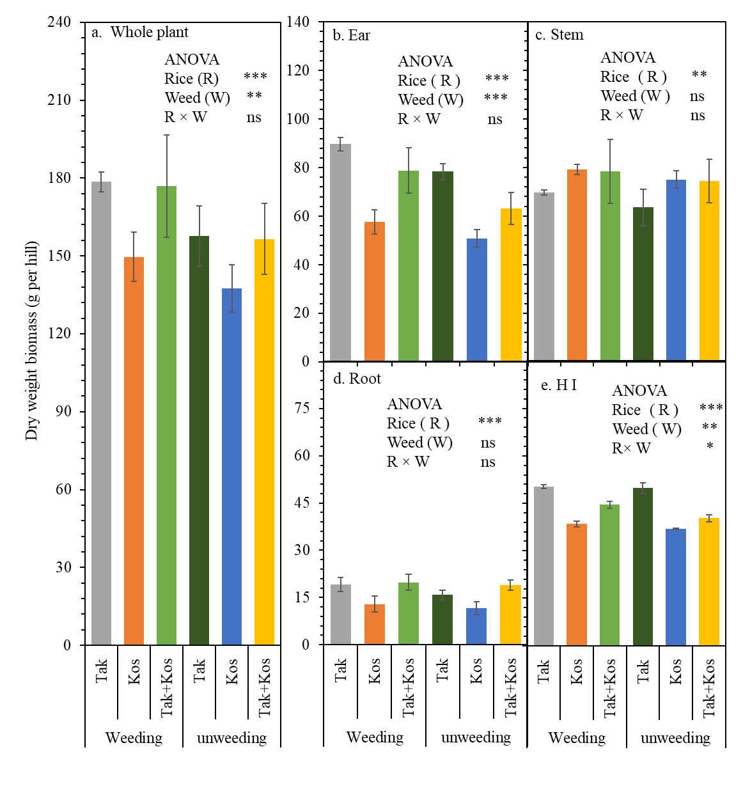
Fig. 1: Dry weight of whole rice plant (a), ear (b), leaf +stem (c), root (d), and harvest index (HI) (e) at harvest of rice cultivar plant grown individually in the pot (Tak, Kos) and interplanting (Tak + Kos). Bar indicates standard deviation (n=3). ANOVA results are inset. ns: not significant; *: P < 0.05; **: P < 0.01 and ***: P < 0.001.
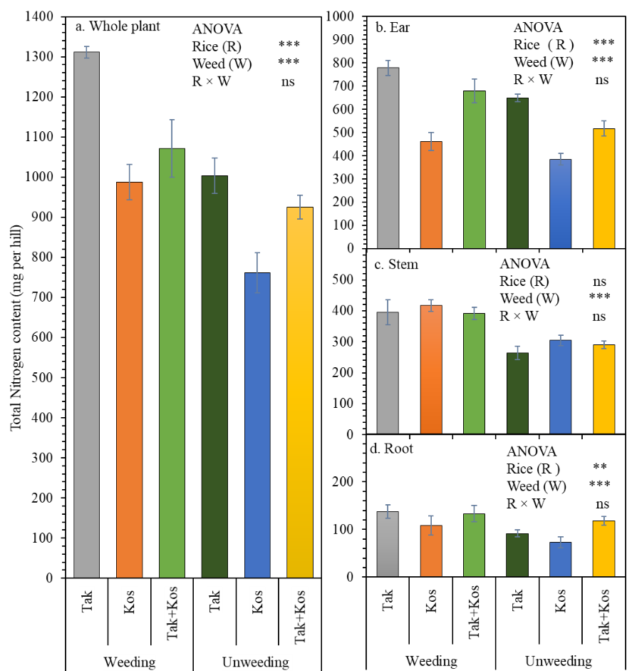
Fig.2: Nitrogen uptake in (mg per Hill) of whole (a) rice plant, ear (b), stem (c), and root (d) at harvest of one rice cultivar plant grown individually in pot and interplanting (Tak+Kos). Bar indicates standard deviation (n=3). ANOVA results are inset. ns: not significant; *: P < 0.05; **: P < 0.01 and ***: P< 0.001

